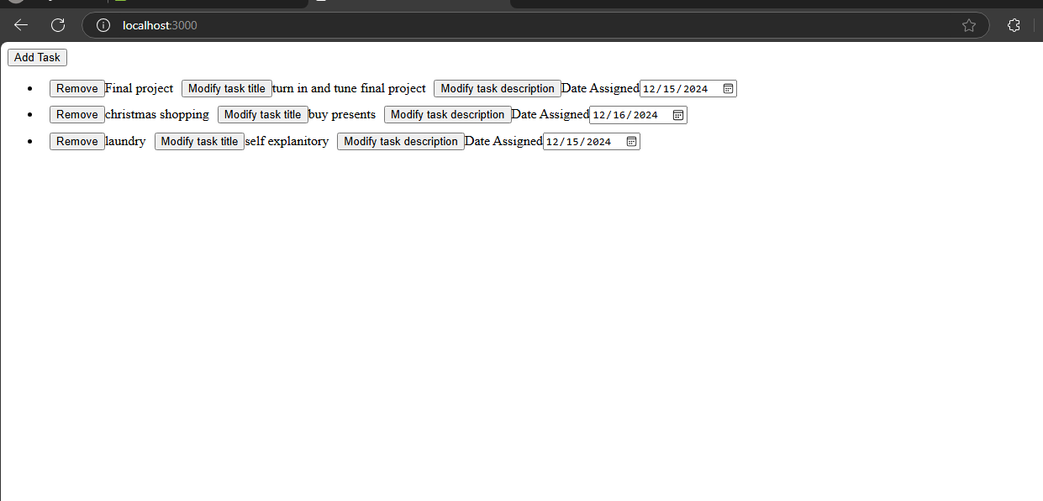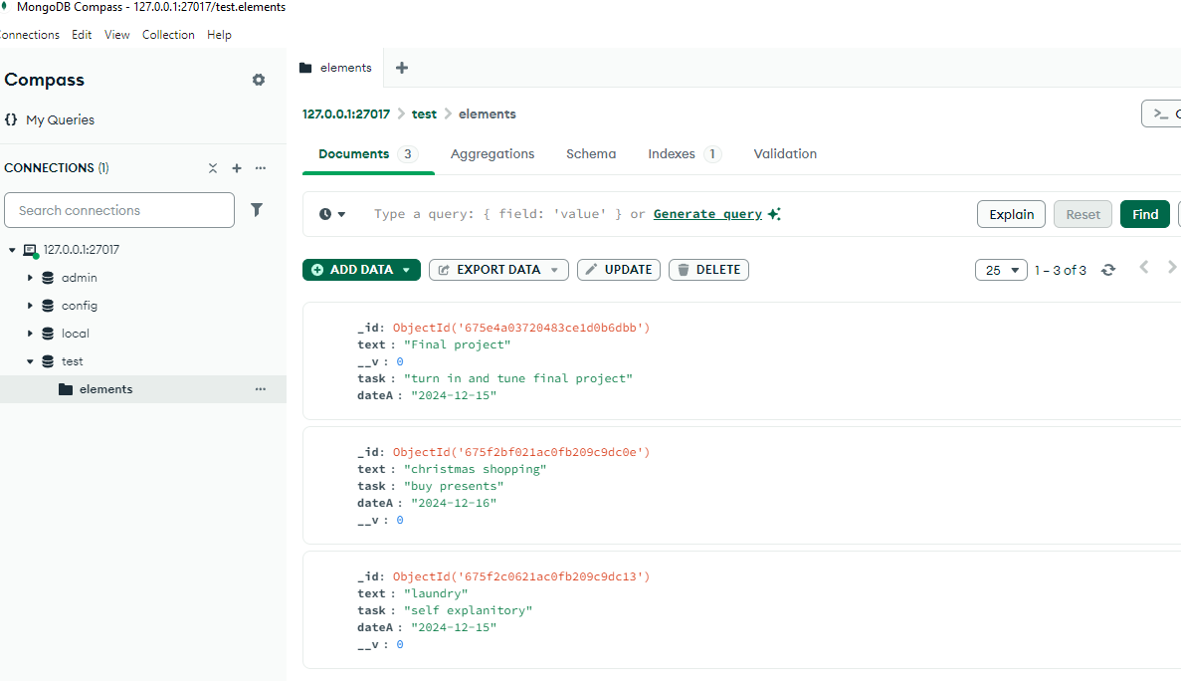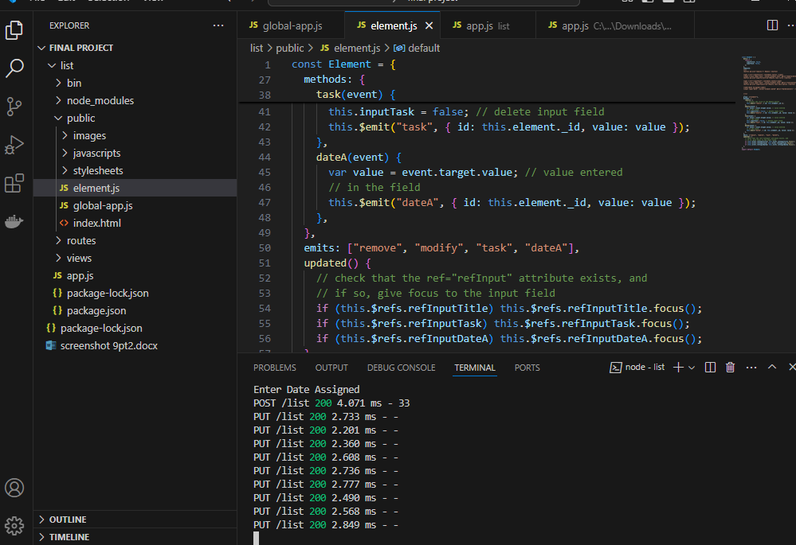

[Web-Apps-Class/final project at main · CoxAlexander/Web-Apps-Class](https://github.com/CoxAlexander/Web-Apps-Class/tree/main/final%20project)